.step-by-step instructions should be given by us to solve the problem. Thus, the success of a computer in solving a problem depends on how correctly and precisely we define the problem, design a solution (algorithm) and implement the solution (program) using a programming language.
StepS for problem Solving: GIGO (Garbage In Garbage Out) The correctness of the output that a computer gives depends upon the correctness of input provided
1.Step’s for problem Solving:
- Analysing the problem : we would be able to figure out what are the inputs that our program should accept and the outputs that it should produce.
- Developing an Algorithm: The solution is represented in natural language and is called an algorithm.
- Coding:
- Testing and Debugging:
- Characteristics of a good algorithm
• Precision — the steps are precisely stated or defined.
• Uniqueness — results of each step are uniquely defined and only depend on the input and the result of the preceding steps.
• Finiteness — the algorithm always stops after a f inite number of steps.
• Input — the algorithm receives some input.
• Output — the algorithm produces some output.
- While writing an algorithm, it is required to clearly identify the following:
• The input to be taken from the user
• Processing or computation to be performed to get the desired result
• The output desired by the user
1.2.Representation of Algorithm’s: There are two common methods of representing an algorithm —flowchart and pseudocode.
1.2.1.Flowchart — Visual Representation of Algorithms
Table .1 Shapes or symbols to draw flow charts
Flowchart symbol | Function Description
 | Start/End | Also called “Terminator” symbol. It indicates where the  flow starts and ends.
 | Process | Also called “Action Symbol,” it represents a process, action, or a single step.
 | Decision | A decision or branching point, usually a yes/no or true/ false question is asked, and based on the answer, the path gets split into two branches.
 | Input/Output | Also called data symbol, this parallelogram shape is used to input or output data
 | Arrow | Connector to show order of flow between shapes.

Example .1: Write an algorithm to find the square of a number.
Before developing the algorithm, let us first identify the input, process and output:
Input: Number whose square is required
Process: Multiply the number by itself to get its square
Output: Square of the number
Algorithm to find square of a number.
Step 1: Input a number and store it to num
Step 2: Compute num * num and store it in square
Step 3: Print square

The algorithm to find square of a number can be represented pictorially using flowchart as shown in Figure 4.2.
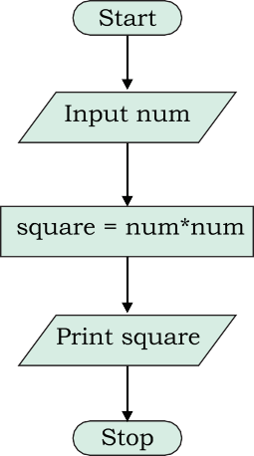
Figure 4.2: Flowchart to calculate square of a number

Example .2: Draw a flowchart to solve the problem of a non-functioning light bulb
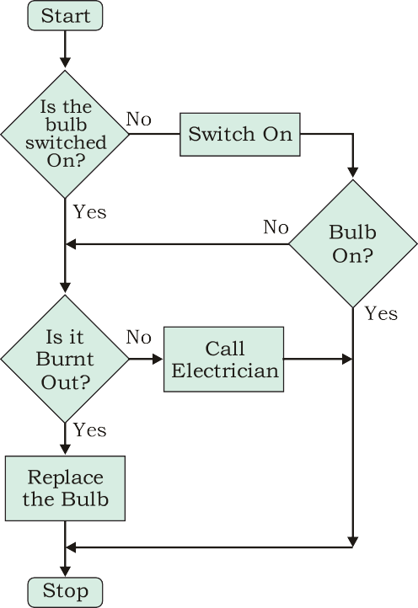
Figure 4.3: Flowchart to solve the problem of a non-functioning light bulb
hink and Reflect
What will happen if an algorithm does not stop after a finite number of steps?
1.2.2 Pseudocode: A pseudocode is another way of representing an algorithm.
No specific standard for writing a pseudocode exists. The word “pseudo” means “not real,” so “pseudocode” means “not real code”.
Following are some of the frequently used keywords while writing pseudocode:
• INPUT
• COMPUTE
• PRINT
• INCREMENT
• DECREMENT
• IF/ELSE
• WHILE
• TRUE/FALSE
Example .3: Write an algorithm to display the sum of two numbers entered by user, using both pseudocode and flowchart.
Pseudocode for the sum of two numbers will be:
INPUT num1 INPUT num2
COMPUTE Result = num1 + num2 PRINT Result
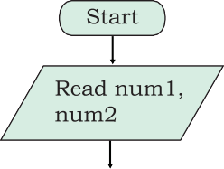
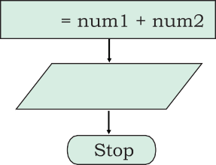
Result
Print Result
Figure 4.4: Flowchart to display sum of two numbers
Example .4: Write a algorithm to calculate area and perimeter of a rectangle, using both pseudocode and flowchart.
Pseudocode for calculating area and perimeter of a rectangle.

Notes

INPUT length INPUT breadth
COMPUTE Area = length * breadth PRINT Area
COMPUTE Perim = 2 * (length + breadth) PRINT Perim
The flowchart for this algorithm is given in Figure 4.5.
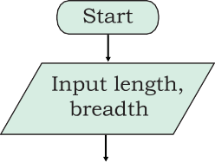
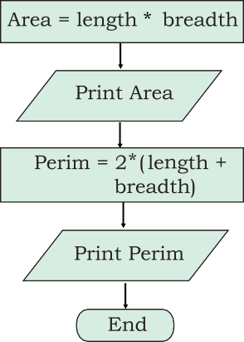
Figure : Flowchart to calculate area and perimeter of a rectangle
pseudocode helps them to review the steps to confirm that the proposed implementation is going to achieve the desire output.
1.3 flow of control:
1.3.1 Sequence: steps are executed one after the other are said to execute in sequence.(eg 1 to eg 4)
1.3.2 Selection: problem involves some decision-making based on certain conditions.
1.3.3 Repetition
1.3.2 Selection :Let us look at some other examples where decision making is dependent on certain conditions. For example,
  - Checking eligibility for voting.
Depending on their age, a person will either be allowed to vote or not allowed to vote:
    - If age is greater than or equal to 18, the person is eligible to vote
    - If age is less than 18, the person is not eligible to vote
  - Let us consider another example
If a student is 8 years old and the student likes Maths put the student in Group A
Otherwise
Put the student in Group B
In which group will these students go as per the above condition?
Outcome
8-year-old Ravi who does not like Maths: Group B
8-year-old Priti who likes Maths: Group A
7-year-old Anish who likes Maths: Group B
- The program checks one or more conditions and perform operations (sequence of actions) depending on true or false value of the condition. These true or false values are called binary values.
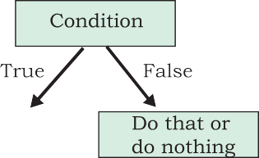
Figure 4.7: Actions depending on true or false of a condition
Example 4.5: Let us write an algorithm to check whether a number is odd or even.
Input: Any number
Process: Check whether the number is even or not
Output: Message “Even” or “Odd”
Pseudocode of the algorithm can be written as follows:
PRINT "Enter the Number" INPUT number
IF number MOD 2 == 0 THEN PRINT "Number is Even"
ELSE
PRINT "Number is Odd"
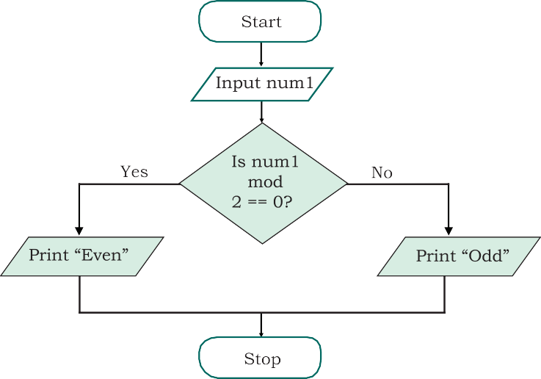
The flowchart representation of the algorithm in shown in Figure 4.8.

Figure 4.8: Flowchart to check whether a number is even or odd
Example 4.6: Let us write a pseudocode and draw a flowchart where multiple conditions are checked to categorise a person as
either child (<13), teenager (>=13 but <20) or adult (>=20),based on age specified:
- Input: Age
- Process: Check Age as per the given criteria
- Output: Print either “Child”, “Teenager”, “Adult”
Pseudocode is as follows:
INPUT Age
IF Age < 13 THEN
PRINT "Child"
ELSE IF Age < 20 THEN
PRINT "Teenager"

ELSE
PRINT "Adult"

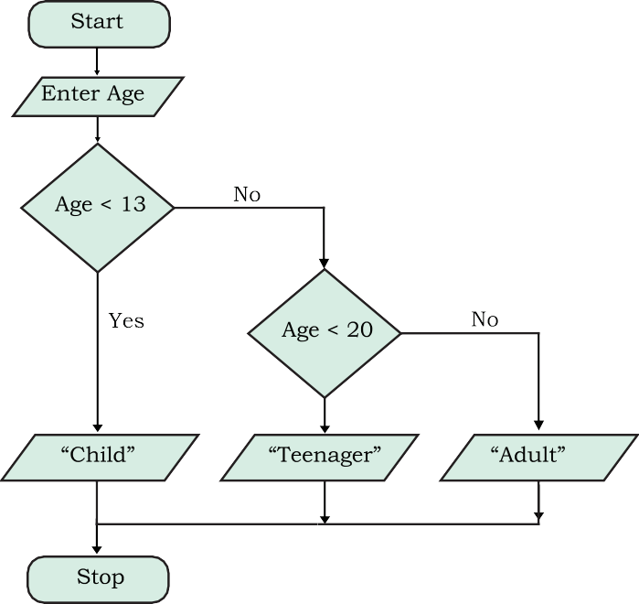
Figure 4.9: Flowchart to check multiple conditions
Example 4.7: Algorithm for a card game called “Dragons and Wizards”.
Make two teams DRAGONS and WIZARDS The rules for the game are as follows:
- If the card drawn is a diamond or a club, Team DRAGONS gets a point
- If the card drawn is a heart which is a number, Team WIZARDS gets a point

- If the card drawn is a heart that is not a number, Team DRAGONS gets a point
- For any other card, Team WIZARDS gets a point
- The team with highest point is the winner Let us identify the following for a card:
Input: shape, value
Process: Increment in respective team scores by one based on the outcome of the card drawn, as defined in the rules.
Output: Winning team
Now let us write the conditionals for this game:
IF (shape is diamond) OR (shape is club)
Team DRAGONS gets a point
ELSE IF (shape is heart) AND (value is number)
Team WIZARDS gets a point
ELSE IF (shape is heart) AND (value is not a number)
Team DRAGONS gets a point

ELSE
Team WIZARDS gets a point
The pseudocode for the program can be as follows: Note: Dpoint (for Dragon) and Wpoint (for Wizard) store points scored by the respective teams.
INPUT shape
INPUT value
SET Dpoint = 0, Wpoint = 0
IF (shape is diamond) OR (shape is club) THEN
INCREMENT Dpoint
ELSE IF (shape is heart) AND (value is number)THEN
INCREMENT Wpoint
ELSE IF (shape is heart) AND (value is not a number)THEN
INCREMENT Dpoint
ELSE
INCREMENT Wpoint
END IF
IF Dpoint > Wpoint THEN
PRINT "Dragon team is the winner"
ELSE
PRINT "Wizard team is the winner"
1.3.3 Repetition:

Lecture Notes – Fundamentals of a Program (C Language)

1. Higher Level Programming Languages
- What is a Compiler?
A compiler is a program that converts high-level language (like C, C++, Java) into machine code that the computer understands.
- Functions of a Compiler:
  - Translates high-level code into machine code.
  - Checks if the syntax (rules of the language) is correct.
  - Reports errors if any, and only creates the executable file after errors are fixed.
✅ Example:
If you write in C:
printf("Hello World");
The compiler converts it into binary instructions like 101010... which the CPU understands.

2. Steps in Writing a Program
Writing a C program is like solving a problem step by step:

Step 1: Define the Program Objectives
- Understand what the program should do.
- Have a clear idea of the goal.
✅ Example: Write a program to calculate the average of 5 numbers.

Step 2: Design the Program
- Plan how the program will work.
- Decide on inputs, outputs, and logic.
✅ Example:
- Input: 5 numbers
- Process: Add them and divide by 5
- Output: Display average

Step 3: Write the Code
- Write the program using C syntax in a text editor.
✅ Example in C:
#include <stdio.h>
int main() {
int a, b, c, d, e;
float avg;
printf("Enter 5 numbers: ");
scanf("%d %d %d %d %d", &a, &b, &c, &d, &e);
avg = (a + b + c + d + e) / 5.0;
printf("Average = %.2f", avg);
return 0;
}

Step 4: Compile
- Convert source code into machine code.
- If there are errors, fix them first.
✅ Example: If you forget a semicolon ;, the compiler will show an error.

Step 5: Run the Program
- Execute the program after successful compilation.
✅ Example Output:
Enter 5 numbers: 10 20 30 40 50
Average = 30.00

Step 6: Test and Debug
- Just because it runs does not mean it is correct.
- Check if it gives the right output in all cases.
- Debug (fix) errors if the program behaves incorrectly.
✅ Example:
If you input negative numbers, does the average still work correctly?

Step 7: Maintain and Modify the Program
- After releasing, programs may need updates.
- Fix bugs or add new features.
✅ Example:
Modify the above program so it can calculate the average of N numbers instead of just 5.

3. Common Mistakes by Beginners
- Skipping planning and directly writing code → Works for small problems, but big mistake for large programs.
- Not testing enough → Programs may run but give wrong results.
- Not breaking down tasks → Always divide work into small steps.

📌 Key Takeaways:
- Always define what you want before coding.
- Design the solution before implementation.
- Use compiler errors as guidance.
- Debugging is part of learning.
- Coding = Problem-solving, not just typing.

Date:30/Aug/2025 Lec:03

Tokens in C

Tokens are the building blocks of a C program, and they are recognized by the C compiler to form valid expressions and statements.

Types of Tokens in C

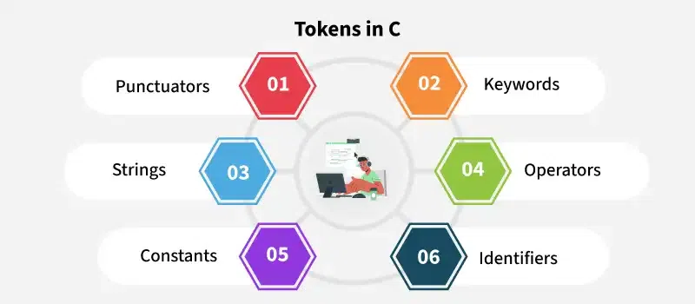

1. Punctuators
The following special symbols are used in C having some special meaning and thus, cannot be used for some other purpose. Some of these are listed below:
- Brackets[]: Opening and closing brackets are used as array element references. These indicate single and multidimensional subscripts.
- Parentheses(): These special symbols are used to indicate function calls and function parameters.
- Braces{}: These opening and ending curly braces mark the start and end of a block of code containing more than one executable statement.
- Comma (, ): It is used to separate more than one statement like for separating parameters in function calls.
- Colon(:): It is an operator that essentially invokes something called an initialization list.
- Semicolon(;): It is known as a statement terminator. It indicates the end of one logical entity. That's why each individual statement must be ended with a semicolon.
- Asterisk (*): It is used to create a pointer variable and for the multiplication of variables.
- Assignment operator(=): It is used to assign values and for logical operation validation.
- Pre-processor (#): The preprocessor is a macro processor that is used automatically by the compiler to transform your program before actual compilation.
- Dot (.): Used to access members of a structure or union.
- Tilde(~): Bitwise One's Complement Operator.
Example:
#include <stdio.h>

int main() {

// '\n' is a special symbol that
// represents a newline
printf("Hello, \n World!");
return 0;
}

2. Keywords:are reserved words that have predefined meanings in C. These cannot be used as identifiers (variable names, function names, etc.). Keywords define the structure and behavior of the program C language supports 32 keywords such as int, for, if, ... etc.
Example:
#include <stdio.h>

int main() {

// 'int' is a keyword used to define
// variable type
int x = 5;
printf("%d", x);

// 'return' is a keyword used to exit
// main function
return 0;
}
Note: The number of keywords may change depending on the version of C you are using. For example, keywords present in ANSI C are 32 while in C11, it was increased to 44. Moreover, in the latest c23, it is increased to around 54.

3. Strings:are nothing but an array of characters ended with a null character (‘\0’). This null character indicates the end of the string. Strings are always enclosed in double quotes. Whereas a character is enclosed in single quotes in C and C++.
Examples:
#include <stdio.h>

int main() {

// "Hello, World!" is a string literal
char str[] = "Hello, World!";
printf("%s", str);
return 0;
}

4. Operators: are symbols that trigger an action when applied to C variables and other objects. The data items on which operators act are called operands.
Example:
#include <stdio.h>
int main() {
int a = 10, b = 5;
// '+' is an arithmetic operator used
// for addition
int sum = a + b;
printf("%d", sum);
return 0;
}

5. Identifiers: are names given to variables, functions, arrays, and other user-defined items. They must begin with a letter (a-z, A-Z) or an underscore (_) and can be followed by letters, digits (0-9), and underscores.
Example:

#include <stdio.h>

int main() {

// 'num' is an identifier used to name

// a variable

int num = 10;

printf("%d", num);

return 0;

}

6. Constants: are fixed values used in a C program. These values do not change during the execution of the program. Constants can be integers, floating-point numbers, characters, or strings.
Examples:

#include <stdio.h>

int main() {

// 'MAX_VALUE' is a constant that holds

// a fixed value

const int MAX_VALUE = 100;

printf("%d", MAX_VALUE);

return 0;

}

Keywords in C

Keywords are predefined or reserved words that have special meanings to the compiler. These are part of the syntax and cannot be used as identifiers in the program. A list of keywords in C or reserved words in the C programming language are mentioned below:
auto | break | case | char | const | continue | default | do
double | else | enum | extern | float | for | goto | if
int | long | register | return | short | signed | sizeof | static
struct | switch | typedef | union | unsigned | void | volatile | while
We cannot use these keywords as identifiers (such as variable names, function names, or struct names). The compiler will throw an error if we try to do so.
Example:

#include <stdio.h>

int main() {

int return = 10;

printf("%d\n", return);

return 0;

}

Category | Keywords
Data Type Keywords
Operator & Utility Keywords
Control Flow Keywords
Storage Class Keywords
Type Qualifiers
User Defined Types

Difference Between Keywords and Identifiers
Keywords | Identifiers
Reserved Words in C that have a specific meaning and use in the syntax | Names given to variables, functions, structs, etc.
Cannot be used as variable names. | Can be used as variable names (if not a keyword).
Examples: int, return, if, while | Examples: x, total, count
Part of the C language grammar. | User-defined, meaningful names in the code.
Cannot be redefined or repurposed. | Can be defined redefined and reused as needed.

Difference Between Variables and Keywords
Variables | Keywords
Used to store data and manipulate data | Reserved words used to define structure and control flow
Created by the user using valid identifiers | Defined by C standard and recognized by the compiler
Examples: age, total, marks | Examples: for, while, int, return
Can hold values and be used in operations | Used to define the structure of C code.
Naming is flexible within identifier rules | Names are fixed and cannot be altered or used differently

LEC-04

C Variables
In C, every variable must be declared before it is used. We can also declare multiple variables of same data type in a single statement by separating them using comma as shown:
data_type name1, name2, name3, ...;

Rules for Naming Variables in C
- A variable name must only contain letters, digits, and underscores.
- It must start with an alphabet or an underscore only. It cannot start with a digit.
- No white space is allowed within the variable name.
- A variable name must not be any reserved word or keyword.
- The name must be unique in the program.

C Variable Initialization
Once the variable is declared, we can store useful values in it. The first value we store is called initial value and the process is called Initialization. It is done using assignment operator(=).
int num = 3;
Note: It is compulsory that the values assigned to the variables should be of the same data type as specified in the declaration.

Accessing Variables
The data stored inside a C variable can be easily accessed by using the variable's name.
Eg:

Changing Stored Values
We can also update the value of a variable with a new value whenever needed by using the assignment operator =.
Eg:

How to use variables in C?
Variables act as name for memory locations that stores some value.
It means that a variable name can be used anywhere as a substitute in place of the value it stores.
Example: An integer variable can be used in a mathematical expression in place of numeric values.

Memory Allocation of C Variables
When a variable is declared, the compiler is told that the variable with the given name and type exists in the program. But no memory is allocated to it yet. Memory is allocated when the variable is defined.
The size of memory assigned for variables depends on the type of variable. We can check the size of the variables using size of operator.
Eg:

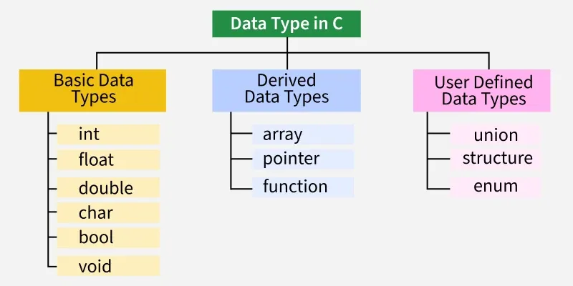

Integer Data Type
The integer datatype in C is used to store the integer numbers (any number including positive, negative and zero without decimal part). Octal values, hexadecimal values, and decimal values can also be stored in int data type in C.
- Range: -2,147,483,648 to 2,147,483,647
- Size: 4 bytes
- Format Specifier: %d
Format Specifier: are the symbols that are used for printing and scanning values of given data types.
Example:
We use int keyword to declare the integer variable:
#include <stdio.h>
int main() {
int var = 22;
printf("var = %d", var);
return 0;
}

Character Data Type:
Character data type allows its variable to store only a single character. The size of the character is 1 byte.
It stores a single character and requires a single byte of memory in almost all compilers.
- Range: (-128 to 127) or (0 to 255)
- Size: 1 byte
- Format Specifier: %c
Example:
#include <stdio.h>
int main() {
char ch = 'A';
printf("ch = %c", ch);
return 0;
}

Float Data Type: is used to store single precision floating-point values. These values are decimal and exponential numbers.
- Range: 1.2E-38 to 3.4E+38
- Size: 4 bytes
- Format Specifier: %f
Example:
#include <stdio.h>
int main() {
float val = 12.45;
printf("val = %f", val);
return 0;
}

Double Data Type: is used to store decimal numbers (numbers with floating point values) with double precision. It can easily accommodate about 16 to 17 digits after or before a decimal point.
- Range: 1.7E-308 to 1.7E+308
- Size: 8 bytes
- Format Specifier: %lf
Example:
#include <stdio.h>
int main() {
double val = 1.4521;
printf("val = %lf", val);
return 0;
}

Literals in C: are constant values assigned to variables. They represent fixed values that cannot be changed. Literals occupy memory but do not have references like variables. Often, the terms constants and literals are used interchangeably.
For example, “const int = 5;“, is a constant expression and the value 5 is referred to as a constant integer literal.

Types of C Literals
There are 4 types of literal in C:
- Integer Literal
- Float Literal
- Character Literal
- String Literal

Escape Sequence in C
• In C, an escape sequence is a special way of writing characters that are hard to type directly on the keyboard or have special meaning.
• They always start with a backslash (\) followed by a letter or number.

Why do we need them?
Some characters can’t be typed easily in a string.
For example:
- How will you put a new line inside a string? You can’t just press Enter inside "Hello".
- Or, what if you want to print a double quote (") inside a string like "This is "C language""?
That’s where escape sequences help.

Example to demonstrate how to use \b escape sequence in C

Meaning of \b
- \b = backspace character
- It moves the cursor one step back in the output.
- If there’s something printed already, the next character can overwrite it.

// C program to illustrate \b escape sequence
#include <stdio.h>
int main(void)
{
// \b - backspace character transfers
// the cursor one character back with
// or without deleting on different
// compilers.
printf("Hello \b\b\b\b\b\bHi PU");
return (0);
}

2. Example to demonstrate how to use \n escape sequence in C
// C program to illustrate \n escape sequence
#include <stdio.h>
int main(void)
{
// Here we are using \n, which is a new line character.
printf("Hello\n");
printf("MCA");
return (0);
}

3. Example to demonstrate how to use \t escape sequence in C
// C program to illustrate \t escape sequence
#include <stdio.h>

int main(void)
{
// Here we are using \t, which is
// a horizontal tab character.
// It will provide a tab space
// between two words.
printf("Hello \t MCA");
return (0);
}
Note: • A tab is usually equal to 8 spaces (depends on the system/IDE).
• That’s why the gap looks bigger than normal spaces.
Escape Sequence | Meaning
\n | New line (moves text to the next line)
\t | Tab space (like pressing the TAB key)
\" | Prints a double quote inside a string
\' | Prints a single quote inside a string
\\ | Prints a backslash \
\0 | Null character (used to end strings in C)

Decision Making in C (if , if..else, Nested if, if-else-if )
In C, programs can choose which part of the code to execute based on some condition. This ability is called decision
making and the statements used for it are called conditional statements.

For example,
#include <stdio.h>
int main() {

// Number of people in the audience
int num = 100;

// Conditional code inside decision making statement
if (num > 50) {
printf("Start the show");
}

return 0;
}

Types of Conditional Statements in C
In the above program, we have used if statement, but there are many different types of conditional statements available in C language:

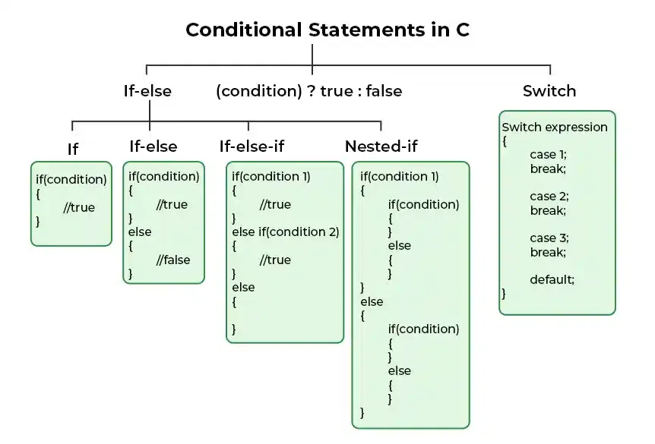

if in C: is the simplest decision-making statement. It is used to decide whether a certain statement or block of statements will be executed or not i.e if a certain condition is true then a block of statements is executed otherwise not.
#include <stdio.h>

int main() {

int i = 10;

// If statement
if (i < 18)
{
printf("Eligible for vote");
}
}
The expression inside () parenthesis is the condition and set of statements inside {} braces is its body. If the condition is true, only
then the body will be executed.

Let's take a look at an example:

Syntax of if in C
if (condition) {
// if body
// Statements to execute if condition is true
}
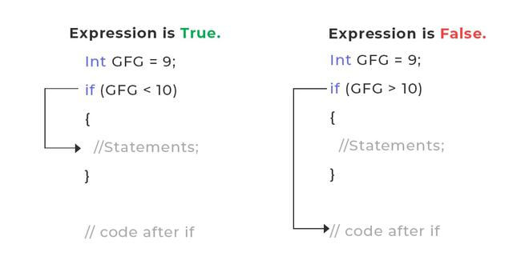
The working of the if statement in C is as follows:
- STEP 1: When the program control comes to the if statement, the test expression is evaluated.
- STEP 2A: If the condition is true, the statements inside the if block are executed.
- STEP 2B: If the expression is false, the statements inside the if body are not executed.
- STEP 3: Program control moves out of the if block and the code after the if block is executed.

Example: Check for Negative Number
We can check whether the number is negative by comparing it with 0 and checking if it is less than zero, it is negative.
#include <stdio.h>

int main() {
int n = -4;

// Condition to check for negative number
if (n < 0) {
printf("%d is Negative", n);
}

return 0;
}

Check if an Integer Lies in the Range
To check whether the number is in the given range, we will need to combine two conditions. One to check for upper limit and one to check for lower limit.
#include <stdio.h>
int main() {
int n = 11;

// Check whether n is the range [10, 20]
if (n <= 20 && n >= 10)
printf("%d is in the range [10, 20]", n);
return 0;
}

Check Whether the Number is Even or Odd
#include <stdio.h>
int main() {
int n = 4;
// Condition to check for even number
if (n % 2 == 0)
{
printf("%d is Even", n);
}
// Condition to check for odd number
if (n % 2 != 0) {
printf("%d is Odd", n);
}
return 0;
}

2. if-else in C
The if statement alone tells us that if a condition is true, it will execute a block of statements and if the condition is false, it won’t. But what if we want to do something else when the condition is false?
#include <stdio.h>

int main() {
int i = 10;

if (i > 18) {
printf("Eligible for vote");
}
else {
printf("Not Eligible for vote");
}
return 0;
}

Negative Number check using If-else statement
#include <stdio.h>

int main() {
int n = -7;

// If the number is negative
if (n < 0)
printf("Negative");

// If the number is not negative
else
printf("Not Negative");

return 0;
}

Check if Integer Lies in the Range
#include <stdio.h>

int main() {
int n = 6;

// Check if the number lies in the range [10, 20]
if (n >= 10 && n <= 20) {
printf("%d lies in range.", n);
}
else {
printf("%d does not lie in range.", n);
}

return 0;
}

Largest Among Three Numbers Using If-else
#include <stdio.h>

int main() {
int a = 1, b = 2, c = 11;

// Finding the largest by comparing using
// relational operators with if-else
if (a >= b) {
if (a >= c)
printf("%d", a);
else
printf("%d", c);
}
else {
if (b >= c)
printf("%d", b);
else
printf("%d", c);
}

return 0;
}

3. Nested if-else in C
A nested if in C is an if statement that is the target of another if statement. Nested if statements mean an if statement inside another if statement. Yes, C allow us to nested if statements within if statements,

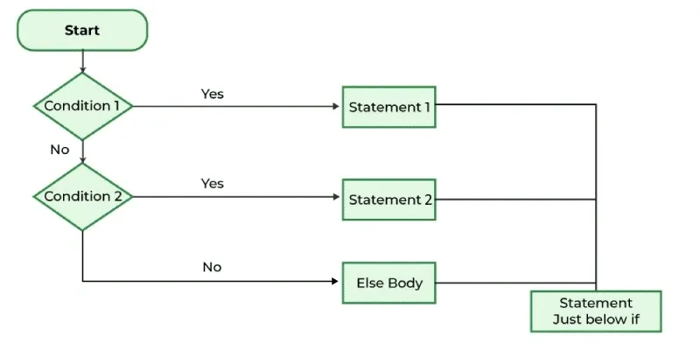

- If Condition 1 evaluates to true, Statement 1 is executed, and the rest of the else if and else conditions are skipped.
- If Condition 1 is false, Condition 2 is evaluated.
- If Condition 2 evaluates to true, Statement 2 is executed, and the else block is skipped.
- If Condition 2 is also false, the Else Body is executed.
- After completing the if-else-if ladder, the statement just below the if are executed.

int main(){
int i = 10;

if (i == 10) {
if (i < 18)
printf("Still not eligible for vote");
else
printf("Eligible for vote\n");
}
else {
if (i == 20) {
if (i < 22)
printf("i is smaller than 22 too\n");
else
printf("i is greater than 25");
}
}

return 0;
}

Check if a number is positive, negative or 0
#include <stdio.h>

int main() {
int n = 10;
printf("Number = %d \n", n);
// Check if the number is positive, negative, or zero
if (n > 0) {
printf("Positive.\n");
} else if (n < 0) {
printf("Negative.\n");
} else {
printf("Zero.\n");
}

return 0;
}

Print the day name using day number
#include <stdio.h>

int main() {
int day = 3;
printf("Day Number: %d\n", day);
// Check the day of the week
if (day == 1) {
printf("Day Name: Monday\n");
} else if (day == 2) {
printf("Day Name: Tuesday\n");
} else if (day == 3) {
printf("Day Name: Wednesday\n");
} else if (day == 4) {
printf("Day Name: Thursday\n");
} else if (day == 5) {
printf("Day Name: Friday\n");
} else if (day == 6) {
printf("Day Name: Saturday\n");
} else if (day == 7) {
printf("Day Name: Sunday\n");
} else {
printf("Invalid day Number\n");
}

return 0;
}

4. if-else-if Ladder in C: are used when the user has to decide among multiple options. The C if statements are executed from the top down. As soon as one of the conditions controlling the if is true, the statement associated with that if is executed, and the rest of the C else-if ladder is bypassed. If none of the conditions is true, then the final else statement will be executed. if-else-if ladder is similar to the switch statement.
#include <stdio.h>

int main() {
int i = 20;

// If else ladder with three conditions
if (i == 10)
printf("Not Eligible");
else if (i == 15)
printf("wait for three years");
else if (i == 20)
printf("You can vote");
else
printf("Not a valid age");

return 0;
}

Print the day name using day number
#include <stdio.h>

int main() {
int day = 3;
printf("Day Number: %d\n", day);
// Check the day of the week
if (day == 1) {
printf("Day Name: Monday\n");
} else if (day == 2) {
printf("Day Name: Tuesday\n");
} else if (day == 3) {
printf("Day Name: Wednesday\n");
} else if (day == 4) {
printf("Day Name: Thursday\n");
} else if (day == 5) {
printf("Day Name: Friday\n");
} else if (day == 6) {
printf("Day Name: Saturday\n");
} else if (day == 7) {
printf("Day Name: Sunday\n");
} else {
printf("Invalid day Number\n");
}

return 0;
}

5. switch Statement in C
is an alternative to the if else if ladder that can be used to execute the conditional code based on the value of the variable specified in the switch statement. The switch block consists of cases to be executed based on the value of the switch variable.
#include <stdio.h>

int main() {

// variable to be used in switch statement
int var = 18;

// declaring switch cases
switch (var) {
case 15:
printf("You are a kid");
break;
case 18:
printf("Eligible for vote");
break;
default:
printf("Default Case is executed");
break;
}

return 0;
}
Note: The switch expression should evaluate to either integer or character. It cannot evaluate any other data type.

6. Conditional Operator in C: s used to add conditional code in our program. It is similar to the if-else statement. It is also known as the ternary operator as it works on three operands.
#include <stdio.h>

int main() {
int var;
int flag = 0;

// using conditional operator to assign the value to var
// according to the value of flag
var = flag == 0 ? 25 : -25;
printf("Value of var when flag is 0: %d\n", var);

return 0;
}

7. Jump Statements in C
These statements are used in C for the unconditional flow of control throughout the functions in a program.

A) break
This loop control statement is used to terminate the loop. As soon as the break statement is encountered from within a loop, the loop iterations stop there, and control returns from the loop immediately to the first statement after the loop.
Example
#include <stdio.h>

int main() {
int arr[] = { 1, 2, 3, 4, 5, 6 };
int key = 3;
int size = 6;

for (int i = 0; i < size; i++) {
if (arr[i] == key) {
printf("Element found at position: %d",
(i + 1));
break;
}
}

return 0;
}

B) continue
the continue statement forces the loop to continue or execute the next iteration. When the continue statement is executed in the loop, the code inside the loop following the continue statement will be skipped and the next iteration of the loop will begin.
#include <stdio.h>

int main() {
for (int i = 1; i <= 10; i++) {

// If i is equals to 6,
// continue to next iteration
// without printing
if (i == 6)
continue;
else
printf("%d ", i);
}

return 0;
}
#include <stdio.h>

int main() {
for (int i = 1; i <= 10; i++) {

// If i is equals to 6,
// continue to next iteration
// without printing
if (i == 6)
continue;
else
printf("%d ", i);
}

return 0;
}

C) goto
referred to as the unconditional jump statement can be used to jump from one point to another within a function
#include <stdio.h>

int main() {
int n = 1;

label: // this is a label (like a bookmark)
printf("%d ", n); // print the current value of n
n++; // increase n by 1

if (n <= 10) // check condition
goto label; // jump back to label if condition true

return 0;
}
- int n = 1;
  - You declare an integer variable n and initialize it with value 1.
- label:
  - This is a label in C, used with goto.
  - Think of it as a "checkpoint" in your program.
- printf("%d ", n);
  - Prints the current value of n.
- n++;
  - Increments n by 1 (so after printing 1, it becomes 2).
- if (n <= 10) goto label;
  - If n is less than or equal to 10, the program jumps back to label.
  - This creates a loop-like behavior using goto.
- When n becomes 11
  - The condition n <= 10 is false, so the program exits the loop and ends.

✅ So basically, this program prints numbers from 1 to 10 using goto instead of a loop like for or while.

